TITLE OF THESES / DISSERTATIONS

عنوان رسالة الماجستير/الدكتوراه باللغة العربية

BY

STUDENT NAME

A thesis/dissertation submitted in partial fulfillment of the requirements for the

Master Degree/ Doctor of Philosophy

Major in Pharmacology

King Saud University

2024 G /1446 H

TITLE OF THESES /DISSERTATIONS

STUDENT NAME

This dissertation is approved as a creditable and independent investigation by a candidate for the Doctor of Philosophy in pharmacology degree and is acceptable for meeting the dissertation requirements for this degree.

_________________________________________

Advisor Name, Ph.D.

Thesis Advisor Date

_________________________________________

Committee Member Name, Ph.D.

Thesis Advisor Date

_________________________________________

Committee Member Name, Ph.D.

Thesis Advisor Date

_________________________________________

Committee Member Name, Ph.D.

Thesis Advisor Date

_________________________________________

Committee Member Name, Ph.D.

Committee Member Name Date

This dissertation is dedicated to

ACKNOWLEDGEMENTS

Write your acknowledgment here in full sentences.

CONTENTS

ABBREVIATIONS………………………………………………………………………vi

LIST OF FIGURES……………………………………………………………………...vii

LIST OF TABLES……………………………………………………………………...viii

ABSTRACT………………………………..…………………………………..…………v

INTRODUCTION……….………………………………………………………………..1

MATERIALS AND METHODS…………………………………………………………2

RESULTS…………………………………………………………………………………2

DISCUSSION…………………………………………………………………………….4

CONCLUSION…………………….…………………………………………….……….5

REFERENCES…………………………………………………………………..…….….5

ARABIC ABSTRACT…………………………………………………………..…….….5

ABBREVIATIONS

mm millimeter

sd standard deviation

se standard error

M molar

conc concentration

LIST OF FIGURES

Figure 1. Time course of effect of Compound A…..…………………………..…………4

Figure 2. Time course of effect of Compound B…………………………………………4

Figure 3. Time course of effect of Compound C…………………………………………4

Figure 4. Time course of effect of Compound D…………………………………………4

LIST OF TABLES

Table 1. Effect of Compound A…………………..…………………………..…………5

Table 1. Effect of Compound B…………………..…………………………..…………5

Table 1. Effect of Compound C…………………..…………………………..…………5

Table 1. Effect of Compound D…………………..…………………………..…………5

# ABSTRACT

TITLE OF THESES / DISSERTATIONS

STUDENT NAME

2024 (G) /1446 (H)

Write your abstract here. (No more than 350 words)

# Introduction

Write your introduction here.

# Material and Methods

Write your introduction here

# Results

Write your results here.

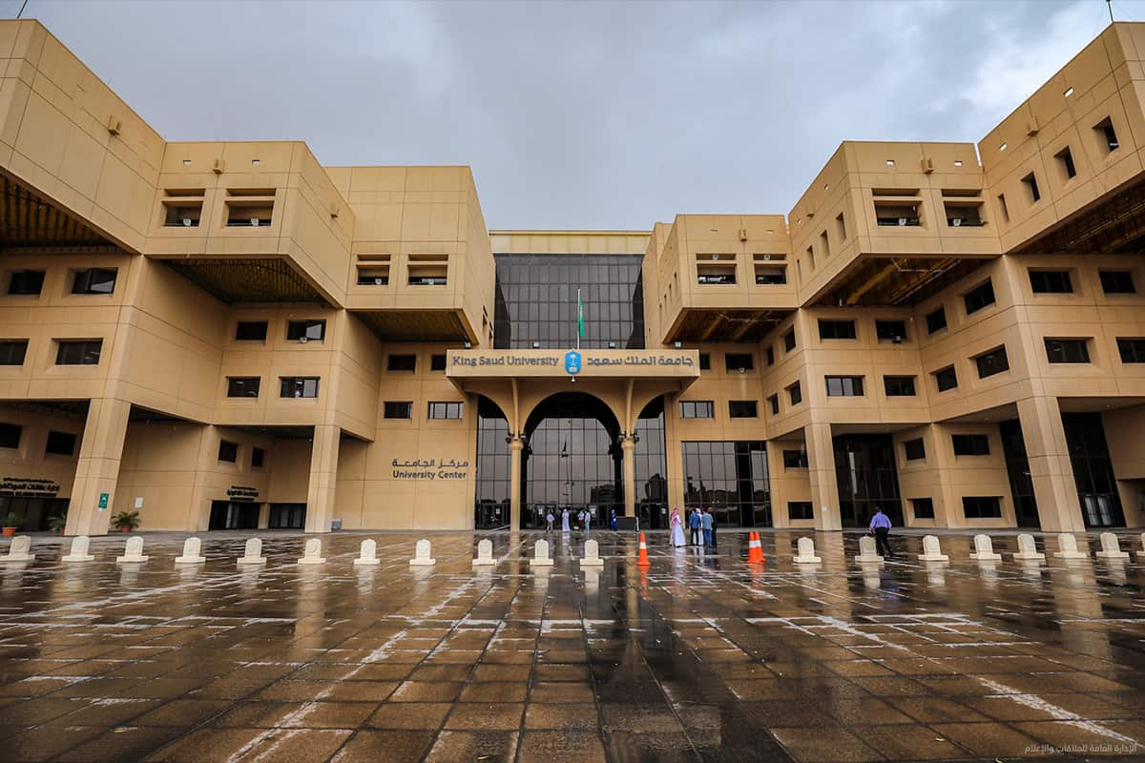

Figure 1. King Saud University Enterance .

"Sed ut perspiciatis unde omnis iste natus error sit voluptatem accusantium doloremque laudantium, totam rem aperiam, eaque ipsa quae ab illo inventore veritatis et quasi architecto beatae vitae dicta sunt explicabo. Nemo enim ipsam voluptatem quia voluptas sit aspernatur au odit aut fugit, sed quia consequuntur magni dolores eos qui ratione voluptatem sequi nesciunt. Neque porro quisquam est, qui dolorem ipsum quia

Table 1. Top 3 TFs regulating the hub genes.

|  |  |  |
| --- | --- | --- |
| Rank | Transcription Factor | Overlapping Genes |
| 1 | CTCF | SPP1, ICAM1, BCL2, NFE2L2, IL6, TGFB1 |
| 2 | TRIM28 | NFE2L2, NOS3 |
| 3 | RELA | NFE2L2, ICAM1, GSK3B |

# Discussion

Write your discussion here

# Conclusion

Write your discussion here

# References

Reference styles differ significantly across disciplines. However, a common rule is that all references should be single-spaced, with a space separating each reference. No reference should be split across pages. This illustrates 3 most common Reference format.

1. Bergen, Phillip J., et al. "Colistin methanesulfonate is an inactive prodrug of colistin against Pseudomonas aeruginosa." Antimicrobial agents and chemotherapy 50.6 (2006): 1953-1958.
2. Bergen, P. J., Li, J., Rayner, C. R., & Nation, R. L. (2006). Colistin methanesulfonate is an inactive prodrug of colistin against Pseudomonas aeruginosa. Antimicrobial agents and chemotherapy, 50(6), 1953-1958.
3. Bergen, Phillip J., Jian Li, Craig R. Rayner, and Roger L. Nation. "Colistin methanesulfonate is an inactive prodrug of colistin against Pseudomonas aeruginosa." Antimicrobial agents and chemotherapy 50, no. 6 (2006): 1953-1958.

# **الملخص باللغة العربية**

اسم الطالب باللغة العربية

قم بكتابة الملخص المترجم هنا باللغة العربية.

# Title Page in Arabic

عنوان رسالة الماجستير/الدكتوراه باللغة العربية

رسالة ماجستير/دكتوراه مقدمة من:

اسم الطالب/ة باللغة العربية

قدمت هذه الرسالة استكمالاً لمتطلبات درجة الماجستير/الدكتوراه في قسم ......... بكلية ....... بجامعة الملك سعود

2024 G /1446 H